**CODE**

**UDPServer**

import java.io.*;

import java.net.*;

public class ServerUDP {

public static void main(String args[]) throws IOException {

byte b[] = new byte[3072];

DatagramSocket dsoc = new DatagramSocket(1000);

FileOutputStream f = new FileOutputStream("receive.txt");

while (true) {

DatagramPacket dp = new DatagramPacket(b, b.length);

dsoc.receive(dp);

f.write(dp.getData(), 0, dp.getLength());

System.out.println("Recieved successfully!");

}

}

}

**OUTPUT**

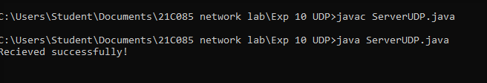

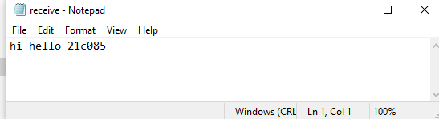

**CODE**

**UDPClient**

import java.io.*;

import java.net.*;

public class ClientUDP {

public static void main(String args[]) throws Exception {

byte b[] = new byte[1024];

FileInputStream f = new FileInputStream("send.txt");

DatagramSocket dsoc = new DatagramSocket(2000);

int i = 0;

while (f.available() != 0) {

b[i] = (byte) f.read();

i++;

}

f.close();

dsoc.send(new DatagramPacket(b, i, InetAddress.getLocalHost(), 1000));

System.out.println("Data sent!");

}

}

**OUTPUT**

